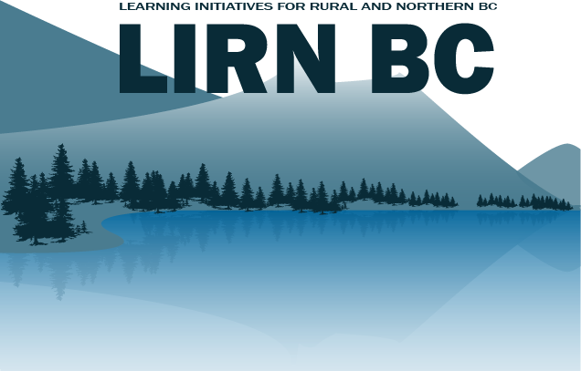
Call for Expressions of Interest 2018/19
Due: Friday, February 23, 2018 at 5:00pm*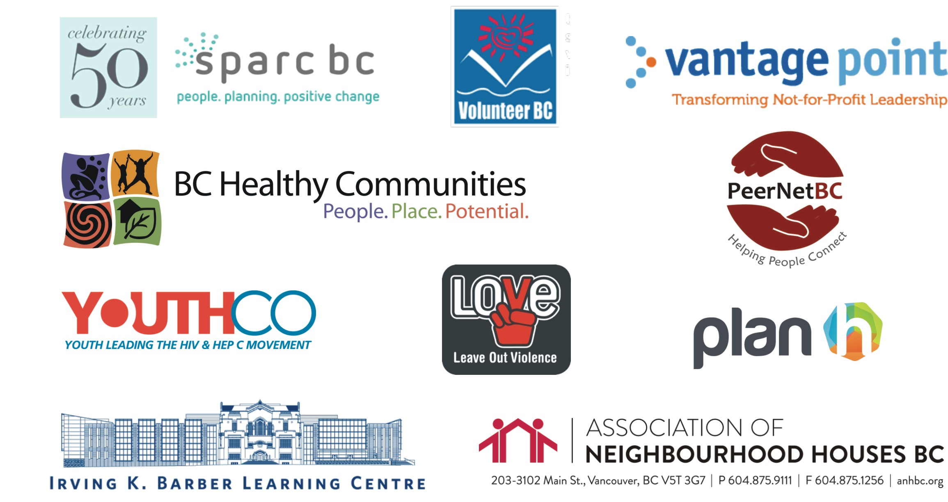
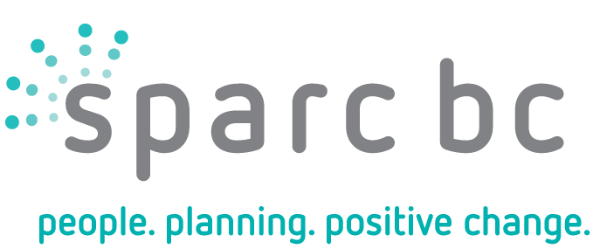

* This deadline is flexible. If you are interested in a workshop, we want to ensure you are able to take the time needed to complete and submit the application form. If you need an extension please contact Sarah at: shuebert@sparc.bc.ca

About Learning Initiatives for Rural and Northern BC (LIRN BC)

LIRN BC brings trainers and facilitators to rural and Northern communities to deliver a meaningful local learning event.
Community stakeholders work together to plan, deliver and evaluate a local learning initiative. LIRN BC is made possible through a partnership of non-government organizations that recognize the strengths and challenges of rural, remote and Northern BC communities.
The support offered by LIRN BC generally includes: event planning, workshop and/or dialogue design, facilitation, training, and collaborative evaluation with the community partner related to each learning event. The community partner is expected to help with planning, marketing, providing a venue, and providing catering if needed.
LIRN BC does not provide direct funding.
The content and format for a LIRN BC event takes shape through discussions between the LIRN BC partners and the local community.
The current LIRN BC partners are:
- Association of Neighbourhood Houses BC (ANHBC)
- BC Healthy Communities (PlanH Program)
- UBC Library, Irving K. Barber Learning Centre
- Leave Out Violence (LOVE) Society of BC
- PeerNetBC
- Social Planning and Research Council of BC (SPARC BC)
- Vantage Point
- Volunteer BC
- YouthCo

Who Can Apply?

LIRN BC will partner with non-profit organizations, First Nations, local/regional governments who:
- Are located in a rural, remote and/or Northern region of BC – rural is defined as communities that are below about 25,000 in population and beyond regular commuting distance from a larger centre;
- Can demonstrate support and/or a partnership within the community (including coordination to avoid multiple applications from the same community);
- Can demonstrate local need for the learning event; and,
- Can articulate anticipated outcomes for a LIRN BC event in their community.
Groups of communities can also apply that are close together or have the potential to use video conferencing facilities or other long-distance communication methods.
We sincerely appreciate your interest in the opportunities offered by LIRN BC. All applications will be reviewed and prioritized by the LIRN BC partners in accordance with an objective list of criteria, which will be organized according to the following themes:
- Community Location;
- Organizational Profile;
- Community Support; and,
- Community Interests, Issues, Assets and Anticipated Outcomes.
The LIRN BC partners will try to provide learning events to as many of the applicants as possible within our budgets.
EXPRESSION OF INTEREST DEADLINE:
Friday, February 23, 2018 at 5:00pm *
Please send completed application to Sarah Huebert at: shuebert@sparc.bc.ca

* This deadline is flexible. If you are interested in a workshop, we want to ensure you are able to take the time needed to complete and submit the application form, however, please do your best to submit the application by the proposed deadline.
APPLICATION

Community Location
Which community, or communities, would be involved in the LIRN BC event? What is the population?

Applicant’s Organizational Profile
Organization’s Name:

Main contact person for this application (email address and phone number):

Alternate contact(s) for this application (email address(es) and phone number(s)):

Organization background information (please include website address and/or a brief statement of your organization’s purpose and activities).

Focus of your Workshop

Please describe what you want your workshop to be about, in what format you would like the workshop presented and what end result you expect in 250 words or less. Based on your workshop interest, you will be connected to an organization that can meet your workshop needs. For some workshop examples, please see the Appendix (p.11).

If you would like some more information, please contact Sarah Huebert at shuebert@sparc.bc.ca

Community Participation
Please create a list with all of the organizations and community partners that you anticipate will attend your workshop.

1.
2.
3.
4.
5.
6.
7.
8.
9.
What resources can you provide towards the workshop (e.g., in-kind time, venue for the event, publicity, catering, etc.)?

EXPRESSION OF INTEREST DEADLINE:
Friday, February 23, 2018 at 5:00pm *
Please send completed application to Sarah Huebert at: shuebert@sparc.bc.ca
* This deadline is flexible. If you are interested in a workshop, we want to ensure you are able to take the time needed to complete and submit the application form, however, please do your best to submit the application by the proposed deadline.
If you have any questions, please contact any of the LIRN BC Partners listed below:

Sarah Huebert  Social Planning and Research Council of BC  Community Development Education Program  shuebert@sparc.bc.ca | Lydia Luk  PeerNetBC  604.733.6186  lydia @peernetbc.com  www.peernetbc.com
Gordon Yusko  Irving K. Barber Learning Centre  604.822.2298  gordon.yusko@ubc.ca | Lawrie Portigal  Volunteer BC  604.379.2311  volunteerbc@gmail.com
Debra Bryant  Association of Neighbourhood Houses of BC  604.875.9111  dbryant@anhbc.org | Nousha Bayrami  Leave Out Violence BC (LOVE)  nousha@leaveoutviolence.org  vancouver@leaveoutviolence.org
Mark Friesen  Vantage Point  604.875.9144  mfriesen@thevantagepoint.ca | Jodi Mucha  BC Healthy Communities Society (PlanH Program)  250.590.08442  jodi@bchealthycommunities.ca
Ghada Dbouba
Peer Education Coordinator
YouthCO HIV & Hep C Society
604-688-1441
GhadaD@youthco.org

About the LIRN BC Partners

Association of Neighbourhood Houses BC (ANHBC)
ANHBC operates seven neighbourhood houses and an outdoor centre in the Metro Vancouver and has associate members in rural communities in BC. ANHBC is a volunteer-directed charitable organization serving communities since 1894. Our mission is to help build healthy and engaged neighbourhoods by connecting people and strengthening their capacity to create change. Each year we welcome nearly 60,000 individuals through our doors. People might come in for childcare or a program for newcomers, to send their kids to camp or find help for a young person or a senior. But they also find a welcoming place to meet neighbours and friends, to share a nutritious meal, to volunteer and to find their own way to contribute to the community.
We work in partnership with hundreds of organizations and are part of an international network of neighbourhood houses and settlements. YourNH.ca gives you some background on the effectiveness of the neighbourhood house model.
BC Healthy Communities (Plan H Program)
BC Healthy Communities Society (BCHC) provides services, programs, and resources to support multi-sectoral collaboration and engagement for creating healthy and resilient communities. BCHC is a province-wide, not-for-profit organization. Part of the World Health Organization’s Healthy Communities/Healthy Cities movement, BCHC was established in 2005, and works with communities around BC.
The PlanH program, a partnership between BC Healthy Communities Society and the provincial Ministry of Health, supports local government, health authority and first nation engagement and partnerships across sectors for creating healthier communities. Recognizing that community policy, plans, and decisions affect health and well-being, PlanH provides facilitated planning and learning processes, workshops, webinars and resources, all based on leading-edge practices for collaborative local action.

UBC Library, Irving K. Barber Learning Centre
The Irving K. Barber Learning Centre is part of the UBC Library system. It’s a multi-purpose facility on Vancouver’s UBC campus where a small team connects and collaborates with other agencies of all kinds. As stated in our charter, we aim to enhance “access to information, knowledge, and innovative teaching through the support of learning and research on an interactive basis with people in British Columbia”.
In order to leverage the resources of our team we look for alignments with our mandate and our ongoing programs. In the context of the LIRN BC collaboration the closest alignments are in three areas:
- The Small Business Accelerator (SBA) program − Use the free tools on this website to structure your market research, grow your business, gauge potential market size or learn the latest industry trends.
- Community-Based Experiential Learning – The Learning Centre, in conjunction with the Centre for Community Engaged provides its community partners with resources to aid them in building relationships with students and facilitating successful projects. A toolkit that is designed to help you develop and build partnerships with students, student leaders, faculty, and staff at the Centre for Community Engaged Learning.
- Webcasts for Community Learning – The Learning Centre captures scholarly content and expert speakers whose presentations are recorded on video. We deliver them online, free of charge through our Webcasts Portal. Explore and search our collection of scholarly webcasts on diverse topics here.
Leave Out Violence (LOVE) Society of BC
Leave Out Violence (LOVE) Society BC is youth-driven, provincially registered non-profit society and federally registered charity. Established in 2001, LOVE BC is part of a network of LOVE organizations primarily based North America. LOVE’s mission is to break the cycle of violence in the lives of young people and in our communities by building a team of youth leaders who communicate a message of non-violence. LOVE uses a unique media arts and leadership based program to support youth begin to examine issues of violence they face, and to explore tools for dealing with their experiences. Participants have identified that the program ensured that they had a chance to actively participate in a non-traditional educational setting, with one youth expressing, “this isn’t like other presentations where people just talk at us.” For more information, visit www.bc.leaveoutviolence.org or the international digital broadcast at www.lovewired.org.
PeerNetBC
PeerNetBC provides training, information and resources for strengthening peer support groups and peer-led initiatives throughout BC, fostering opportunities for people to learn from each other and to make new connections in their communities. People with strong connections to others have improved health and communities where people are connected are healthier places to live.
PeerNetBC programs include capacity-building workshops on group development and group facilitation, information and resources for facilitators and group leaders, curriculum development for organizations that develop and support peer-led groups, youth and community engagement, inclusion, power and diversity. For more information about PeerNetBC visit www.peernetbc.com.

SPARC BC (Community Development Education Program)
SPARC BC, a registered non-profit society and a federally registered charity, was established in 1966 and is a leader in research, public education and advocacy regarding issues of community development, accessibility, and income security. SPARC BC is a provincial organization with over 15,000 members and is governed by a Board of Directors from across BC. SPARC BC’s mission is to work with communities in building a just and healthy society for all.
The Community Development Education Program is one of our methods for realizing our mission. The Community Development Education Program aims to empower individuals and organizations by providing them with learning opportunities to identify local assets and issues, build local knowledge and develop skills and action-plans that contribute to effecting local consensus-oriented change. The curriculum resources and facilitation services of the Community Development Education Program are available to communities through the LIRN BC process. For more information about SPARC BC and the Community Development Education Program, please visit www.sparc.bc.ca.
Vantage Point
Building on more than 70 years as a not-for-profit, Vantage Point convenes, connects and equips sector leaders – executive directors, board directors, and senior managers – through interactive learning and professional development that is immediately applicable. Dedicated volunteer industry leaders and facilitators deliver most of Vantage Point’s programs, supporting the sector with an abundance of expertise and knowledge. With our focus on the strengths and opportunities of the not-for-profit sector, Vantage Point is lifting the capacity of our clients, building a network of generative leaders, and transforming not-for-profit leadership. Visit thevantagepoint.ca.
Volunteer BC
For over 30 years, Volunteer BC has been the provincial leader in promoting the value and impact of volunteerism and enhancing the abilities of volunteer-involving organizations. Volunteer BC mobilizes the collaborative spirit, expertise and energy of all participants in the volunteerism movement to build a better British Columbia. The Volunteer BC membership includes two strong and expansive networks that are at the centre of all aspects of the volunteer experience and that are capable of reaching almost every volunteer in the province. Over 30 volunteer centres province wide form our primary network. They are local catalysts of community involvement, act as clearinghouses of resources to connect individuals to volunteer opportunities, and provide support to local and grassroots organizations in involving volunteers.
Volunteer BC is also a founder of the Voluntary Organizations Consortium of BC (VOCBC), a convening network with a broad membership, provincial and national connections, and extensive knowledge of the sector. Consortium members (over 30 organizations and counting) are provincial in scope and involve volunteers in a variety of areas, including sport, recreation, the arts, health, education, and social services, to name a few.

YouthCO
YouthCO HIV and Hep C Society is a youth-run organization that has been providing peer-lead education for 18 years. We facilitate workshops developed by and for youth that are accessible, engaging, and participatory. Our peer-education programs use a variety of approaches to engage youth from different populations including, trivia games, interactive storytelling, arts-based media, and experiential education. Our highly trained youth facilitators lead young people in discussions about topics such as HIV, Hep C, safer sex, self-esteem, drug use, social justice, personal values, decolonization, and healthy relationships. For more information about YouthCO, visit www.youthco.org.

Appendix

Workshop Examples

The workshops provided by LIRN are meant to be tailored to your community’s specific needs. The listed workshop topics and goals are not all inclusive and the possibilities for topics and goals are extensive and meant to be led and driven by your community.

Workshop topics include but are not limited to:

- Housing;
- Strategic planning;
- Research methods;
- Community development;
- Budgeting;
- Health;
The following are some examples of potential workshop goals:

- Helping community leaders to understand and use information about the community and the region to make strategic decisions.
- Building partnerships across organizations (service clubs), institutions (local government, hospitals, schools, churches) and Aboriginal organizations.
- Creating traditional institutions (local government, schools, churches, businesses, etc.) that are action oriented and responsive to the needs of the people in the community.
- Local government and community organizations carefully plan for the future through better resource utilization.
- Community members have opportunities to strengthen individual skills.

